NEWS RELEASE

CELEBRATING 10 YEARS OF THE VETERANS CASH SCRATCH OFF TICKET

AUSTIN, Texas. (October 29, 2019) — The Texas Department of the Veterans of Foreign Wars celebrates 10 years of the Texas Lottery Commission Veterans Cash scratch off ticket at a press conference held at the Texas State Capitol. The scratch off ticket has raised over 120 million dollars and helped over 300,000 Texas veterans. Present at the press conference were Commissioner J. Winston Krause of the Texas Lottery Commission; Commissioner Al Cantu of the Texas Veterans Commission; Representative Chris Turner, the bill’s original co-author; Dan West, Executive Director of the Texas VFW Foundation & State Adjutant/Quartermaster of the Texas VFW; and Tom Palladino, Executive Director of the Texas Veterans Commission.

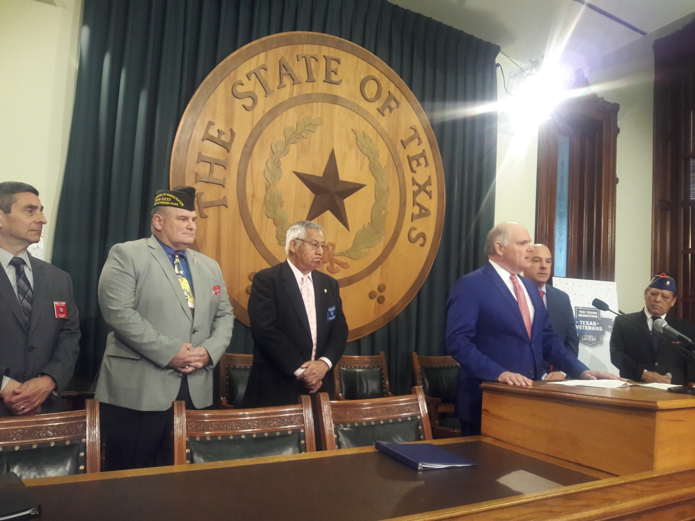
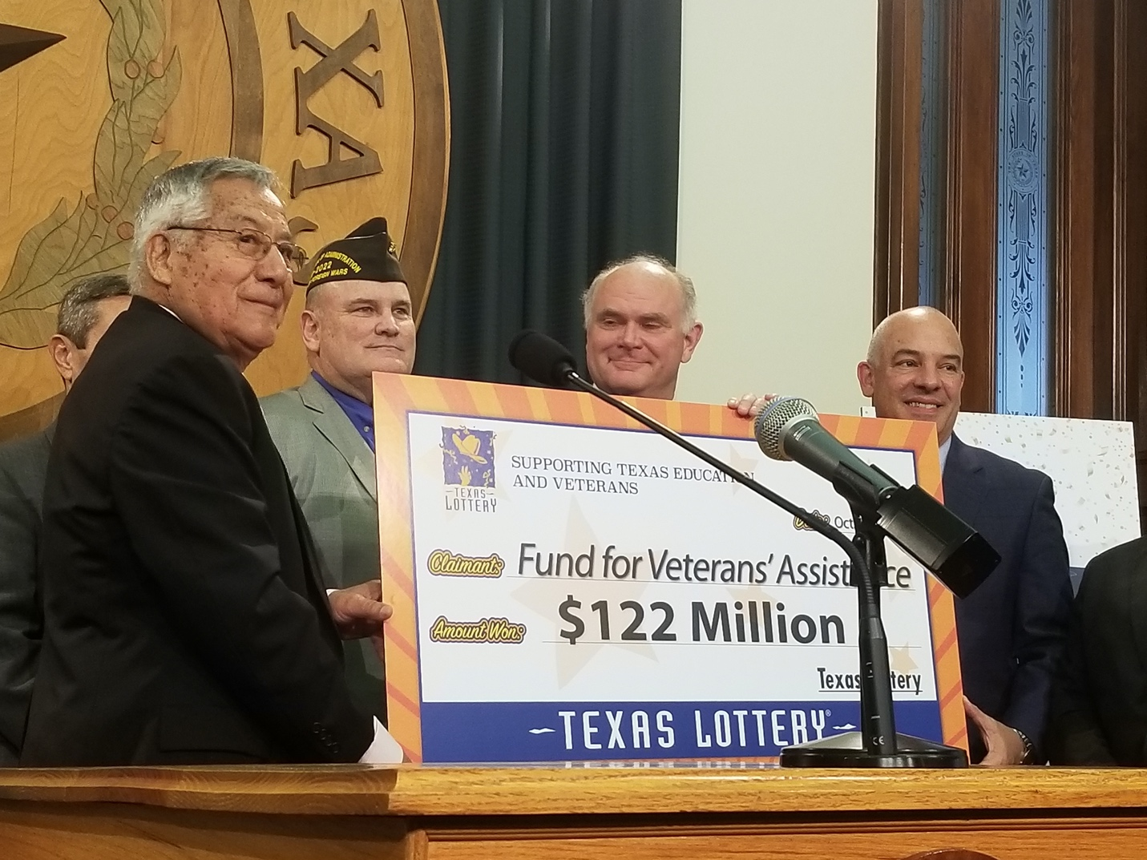

-TEXAS VFW-

Contact: Dan West, dan@texasvfw.org or Terri Sheets, terri@medianation.net

